Term Project – Task 3

Website Creation and Database Implementation

Huzaifa Ahmed Khan - 60095630

Luis Thomas Avelino Vaz - 60095680

Mikhaelle Uzulyao Samson Pablico – 60094909

CP 2445 - 1

Dr. Chima Adiele

November 24th, 2020

# Problem Domain - QREC Website

# Qatar Real Estate Company (QREC) is located in the West Bay area of Doha, Qatar. The main business of QREC is to rent, buy, or sell property for clients. QREC perform other duties, such as study property listings, interview prospective clients, accompany clients to property sites, discuss conditions of sale, and draw up real estate contracts. QREC also includes agents who represent buyers.

Individuals who want to sell their houses sign a contract with **QREC** and provide information on their house. This information is kept in a database by **QREC** and this information is made available to all listing services used by other real estate agents in Qatar.

**Task 3 –**

Design and create a real estate website for QREC consisting of at least three forms that connects to your QREC database in HTML and SQL (use a scripting language on the server side).

a. Users should be able to search for property using certain attributes

b. Users should be able to list available property and see when they became available

c. Users should be able to list properties that were sold and see when they were sold

**NOTE:**

* All data is currently stored in Luis’ phpAdmin account (60095680), if necessary let us know and we will implement it in each of our individual accounts.
* Link to sit server: [https://sit.cna-qatar.edu.qa/~60095680](https://sit.cna-qatar.edu.qa/~60095680/) (under project directory)
* Link to main webpage: <https://sit.cna-qatar.edu.qa/~60095680/Project/homepage.php>

**Screenshots of each Webpage:**

1. Home page (homepage.php)

Description: The Home page is the landing page. It contains links to most of the other pages. This includes the Home Page, Admin Page, Search Page, Available Estates, Sold Estates, About, Buy, Sell and Book Appointment pages. All pages also contain the same navigation bar as displayed on the Home page.

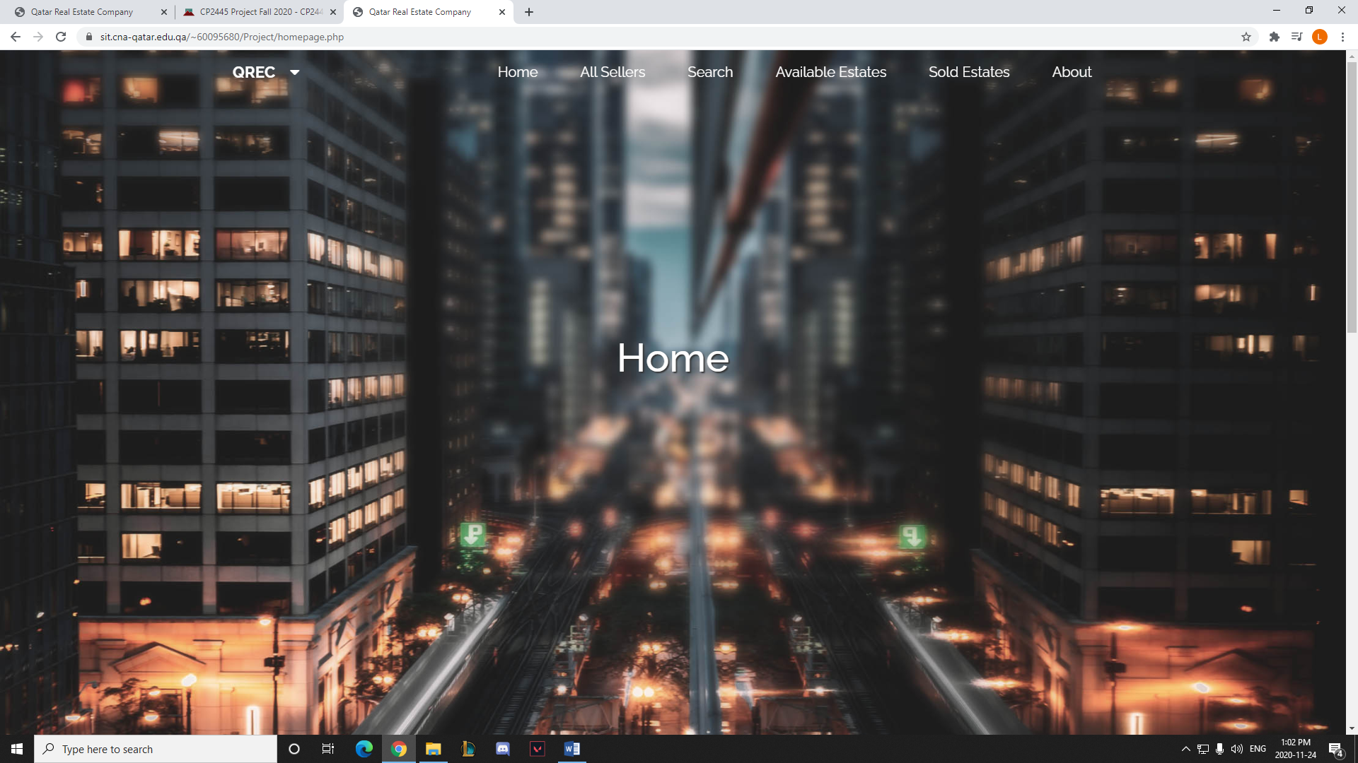

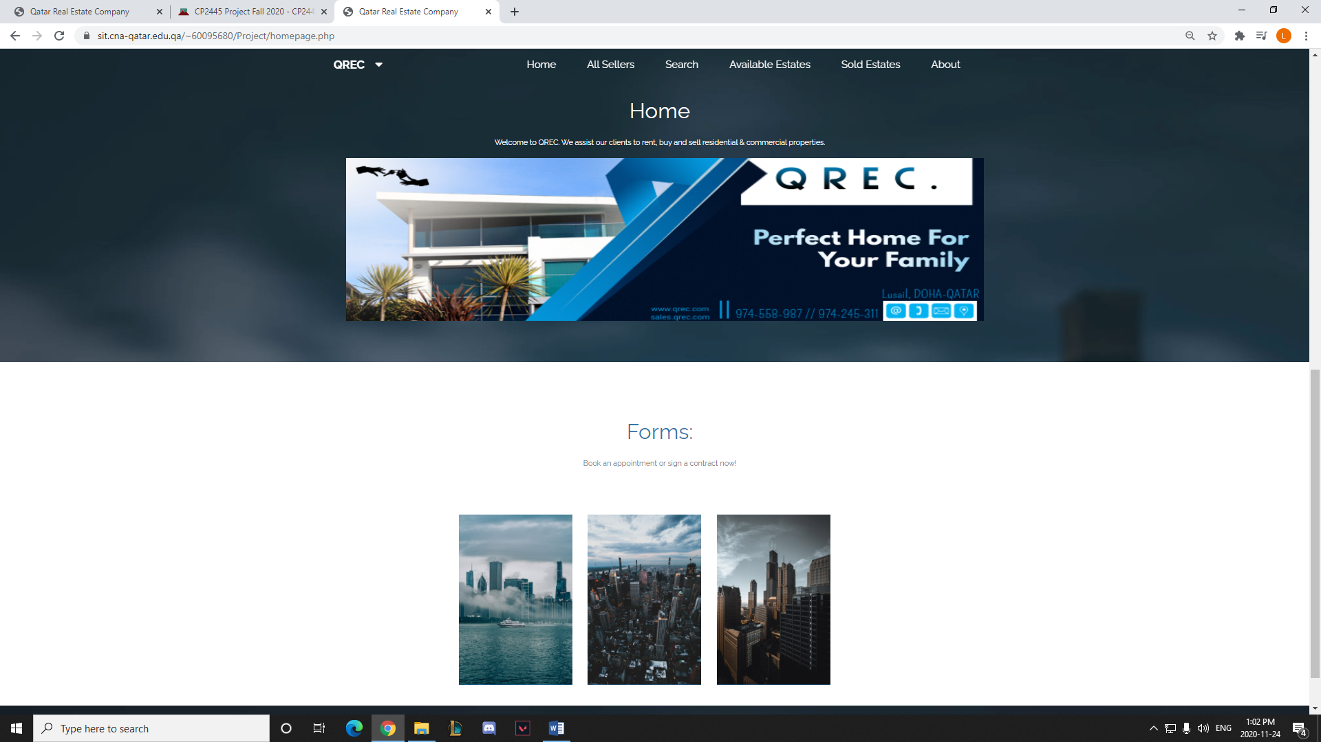

1. All Sellers (allseller.php)

Description: A list of all the sellers selling estates and their contact information.

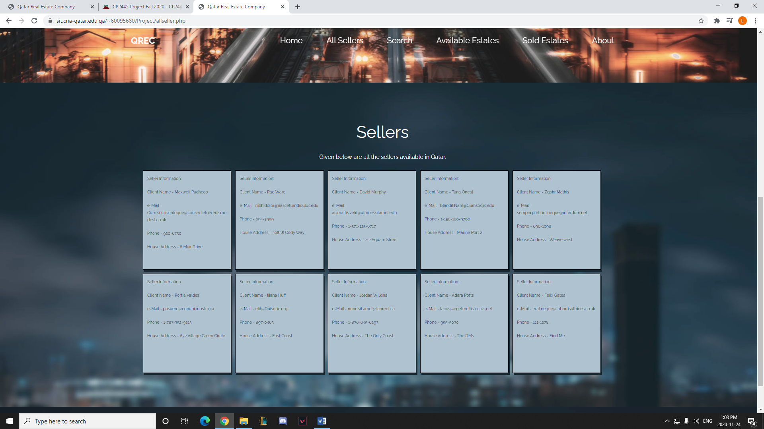

1. Search (search.php)

Description: On the Search page the user can search for any data, specifically an address or a detailing keyword and it will either drop down a list of options existing in the database or they can click the search button which will take them to the Search Results page.

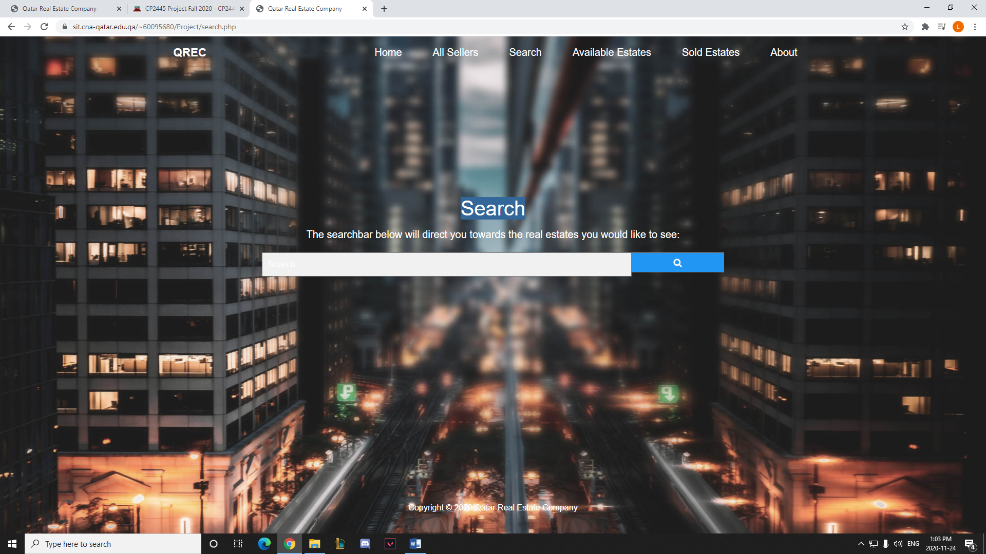

1. Search Results (searchresult.php)

Description: The search results page will display all available data depending on what the user input on the search page. If there is data related to the search, it will display and will include a “Show Details” button which leads to the Details page.

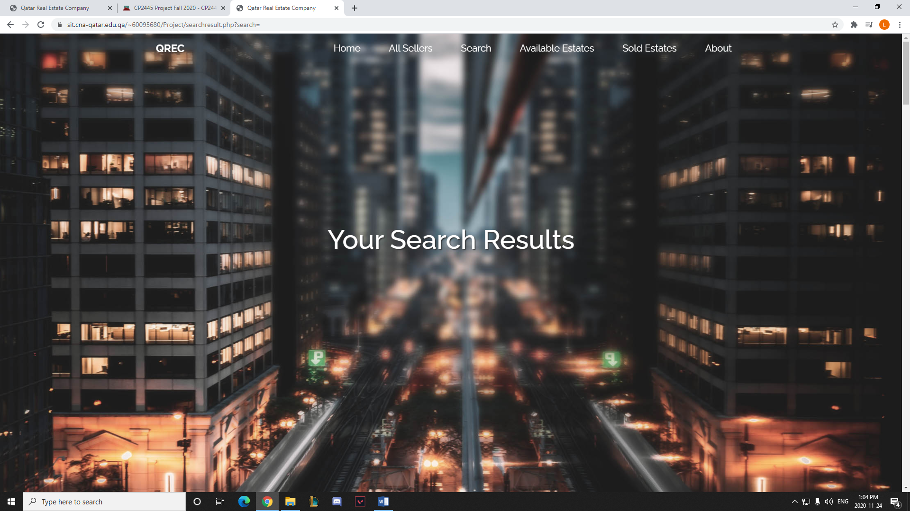

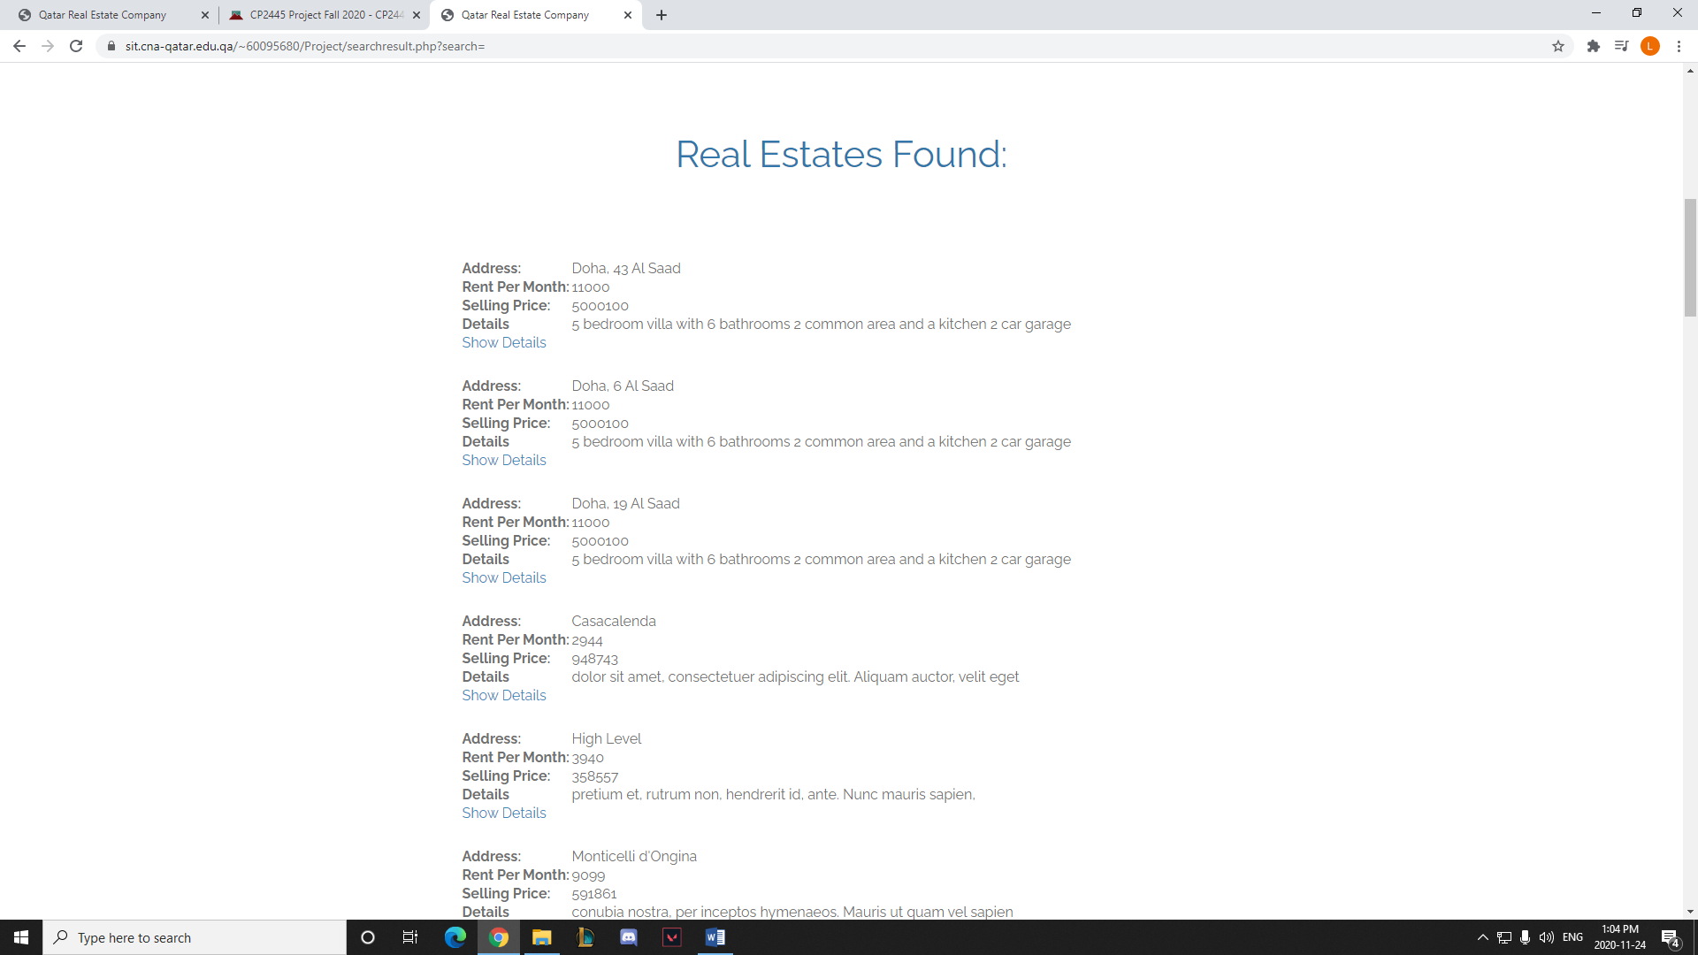

1. Details (details.php)

Description: The details page will display the data of one specific item selected in the search results or in the Available Real Estates page.

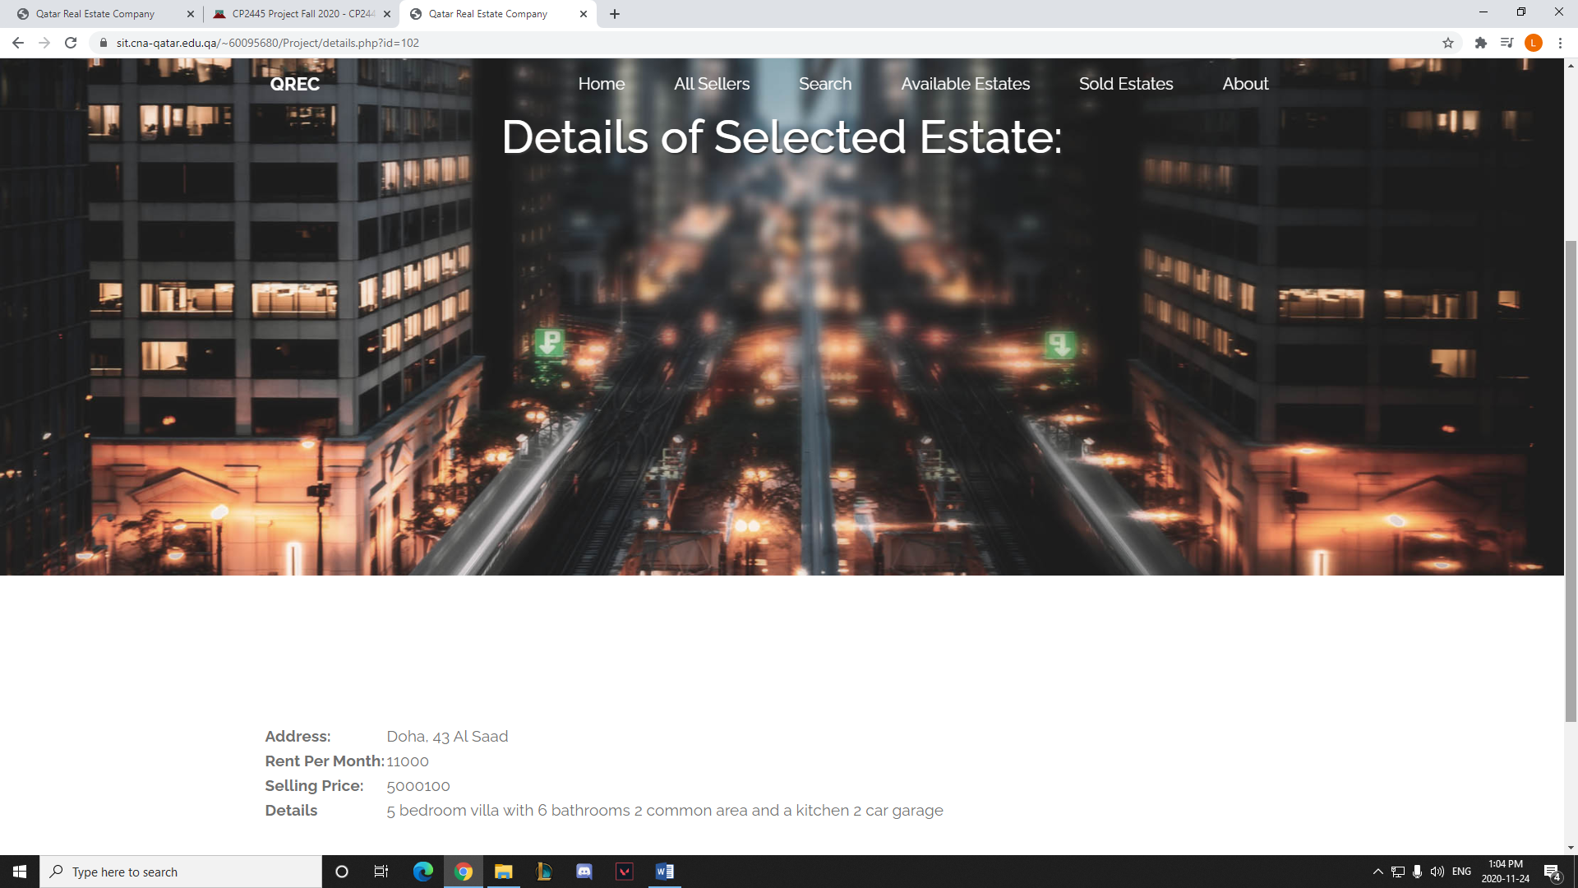

1. Available Estates (realEstateListing.php)

Description: Displays all the available real estates with their respective sellers, as well as all the different types of estates available linked to the details page of the specifically selected estate.

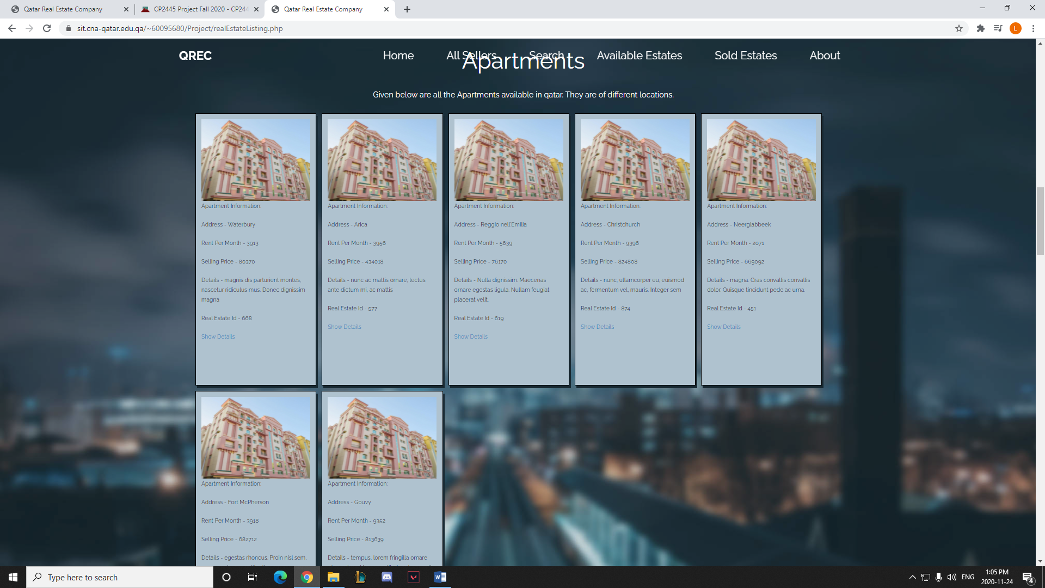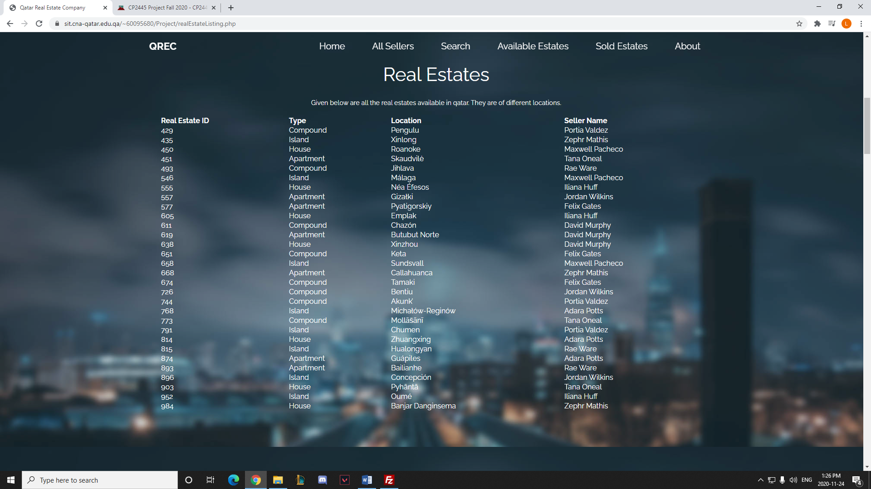

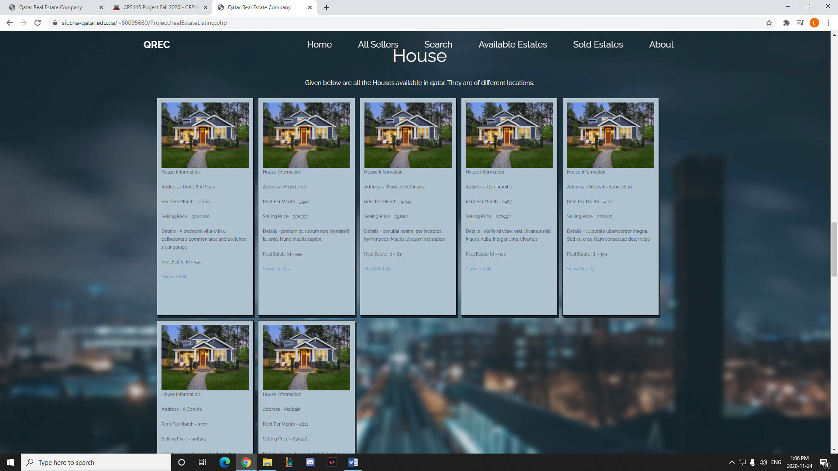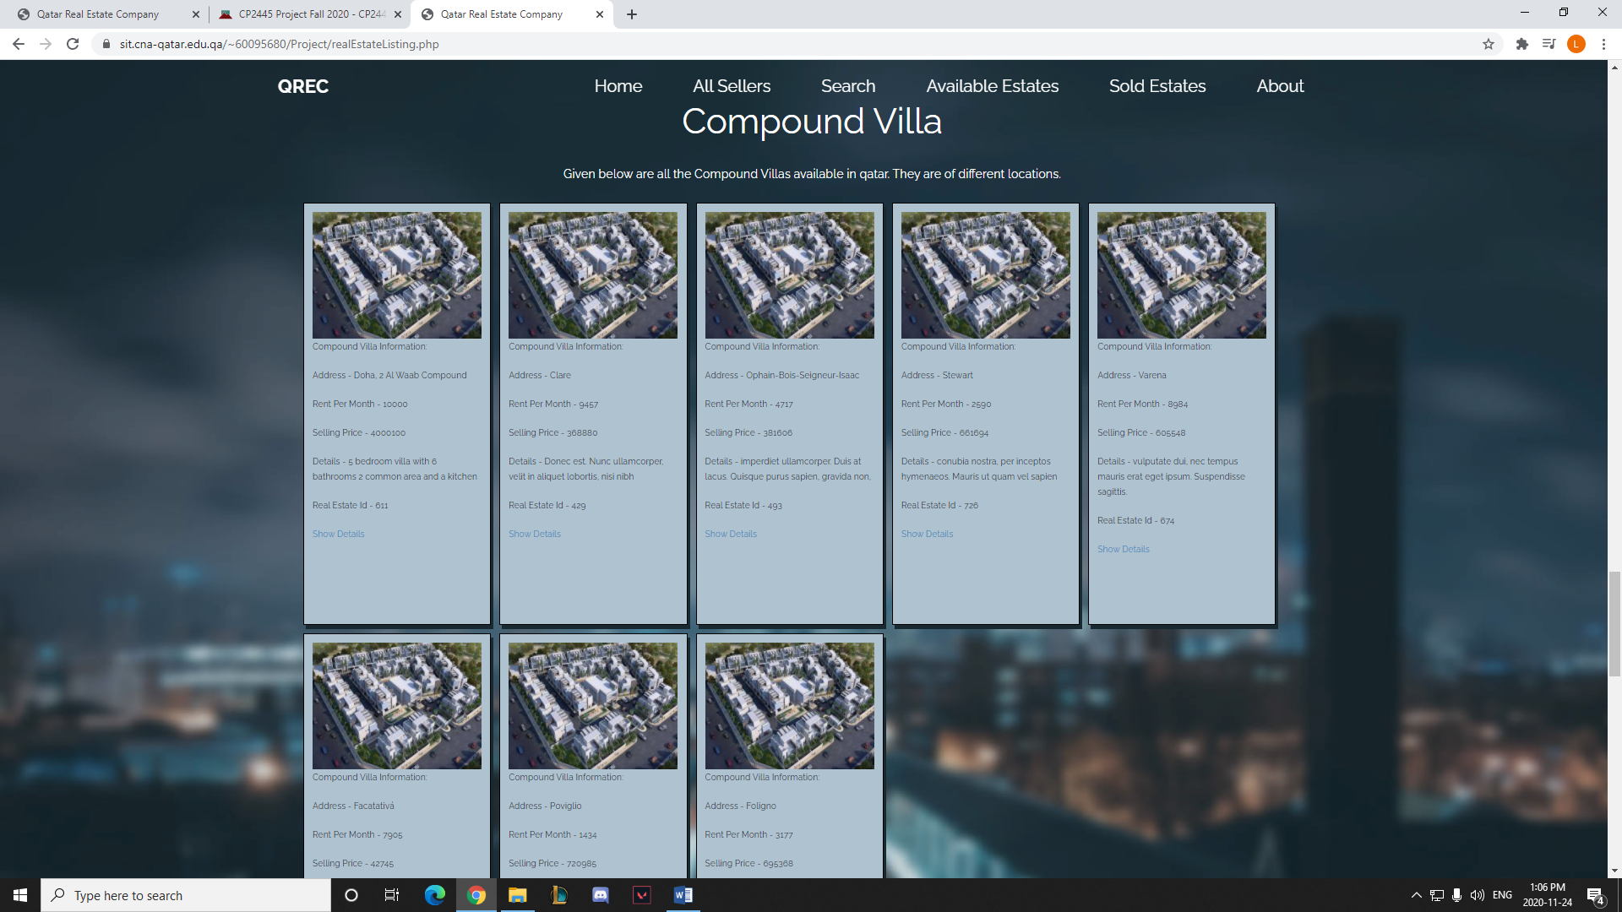

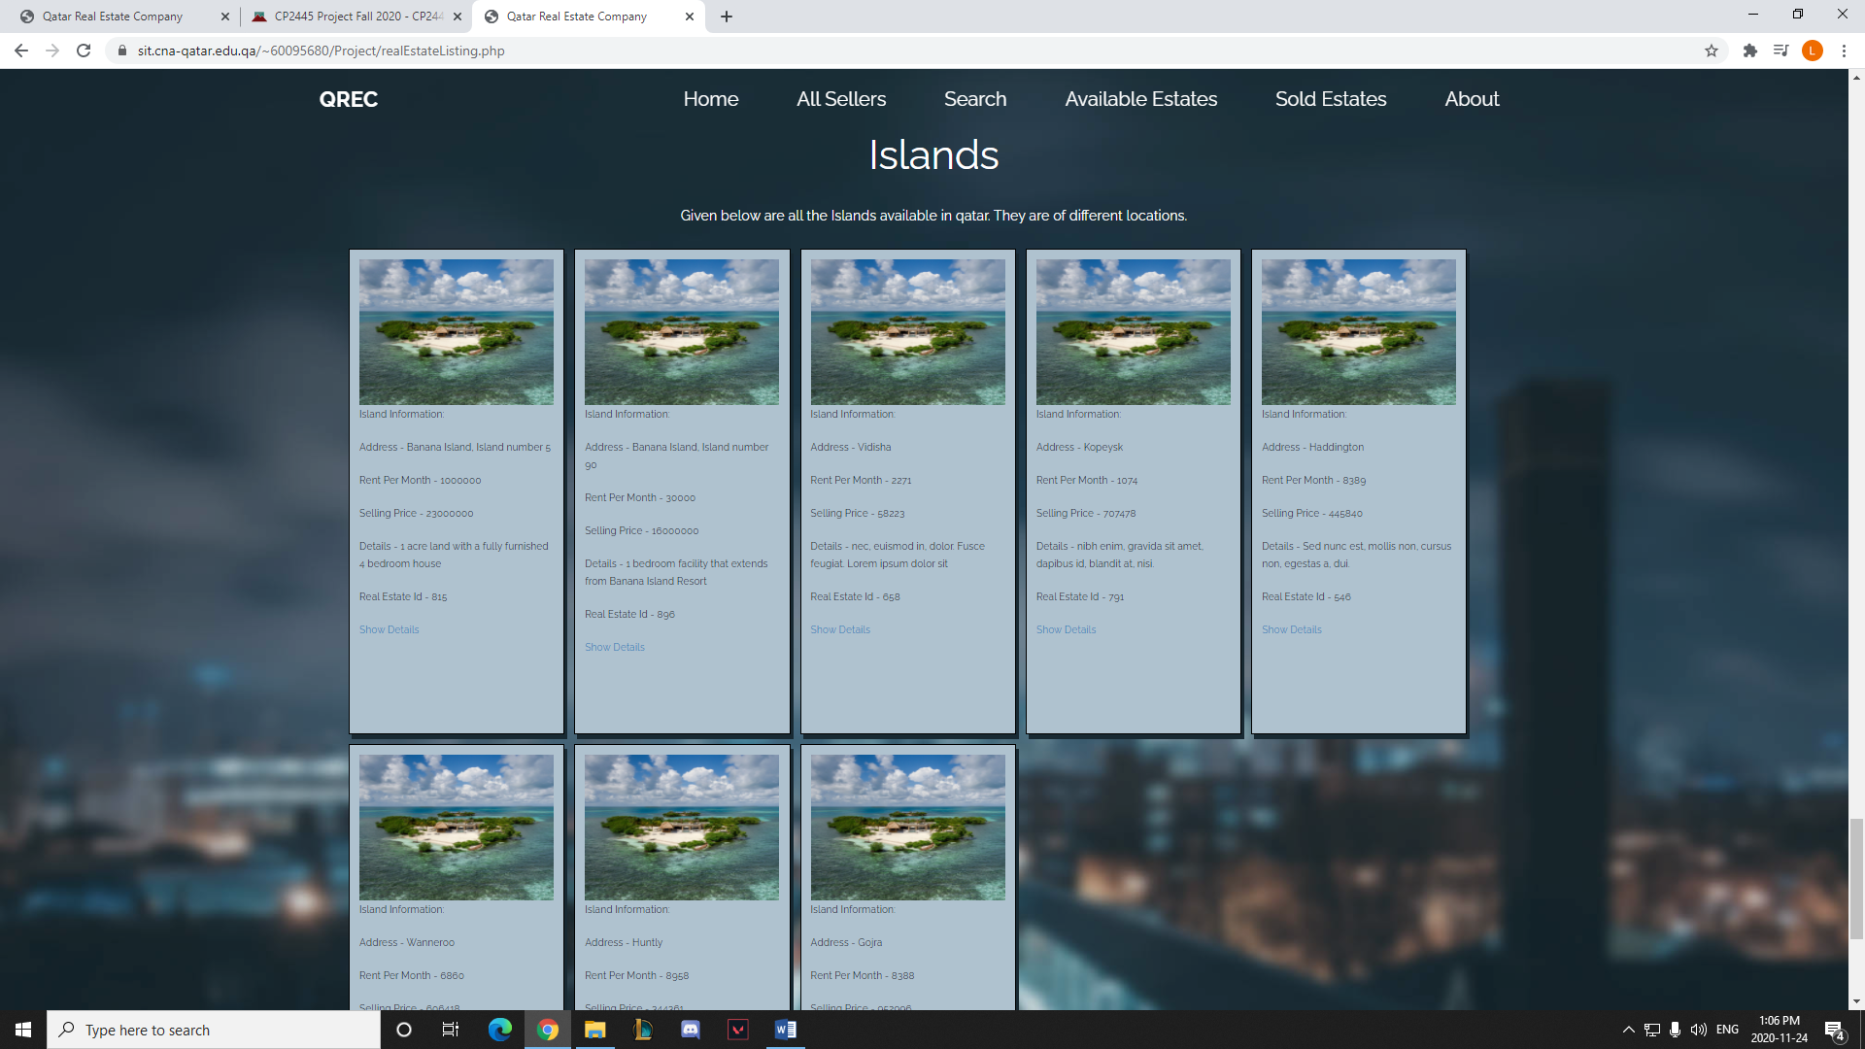

1. Sold Estates (soldEstateListing.php)

Description: Displays all the sold real estates with their respective sellers, as well as all the different types of estates sold.

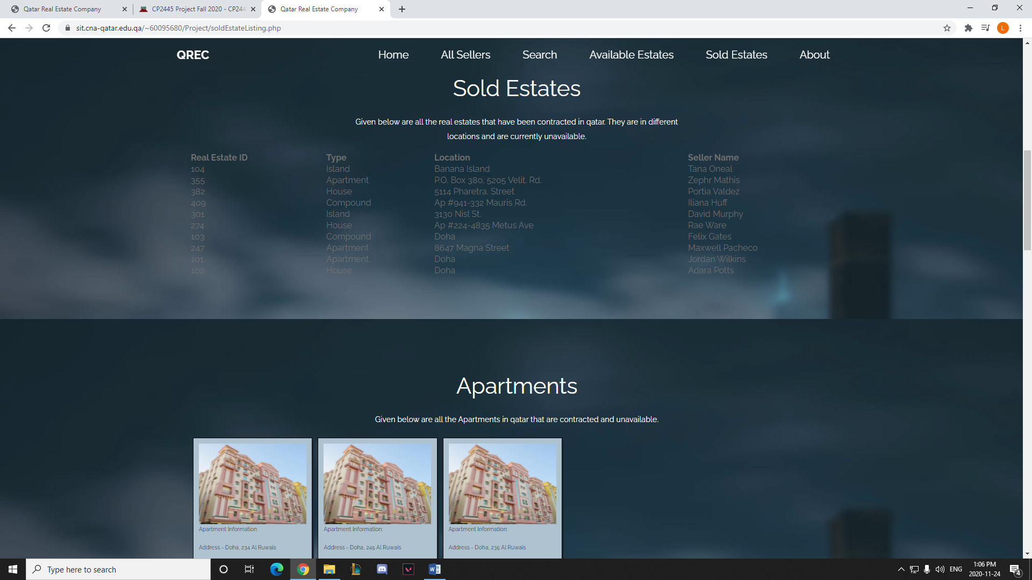

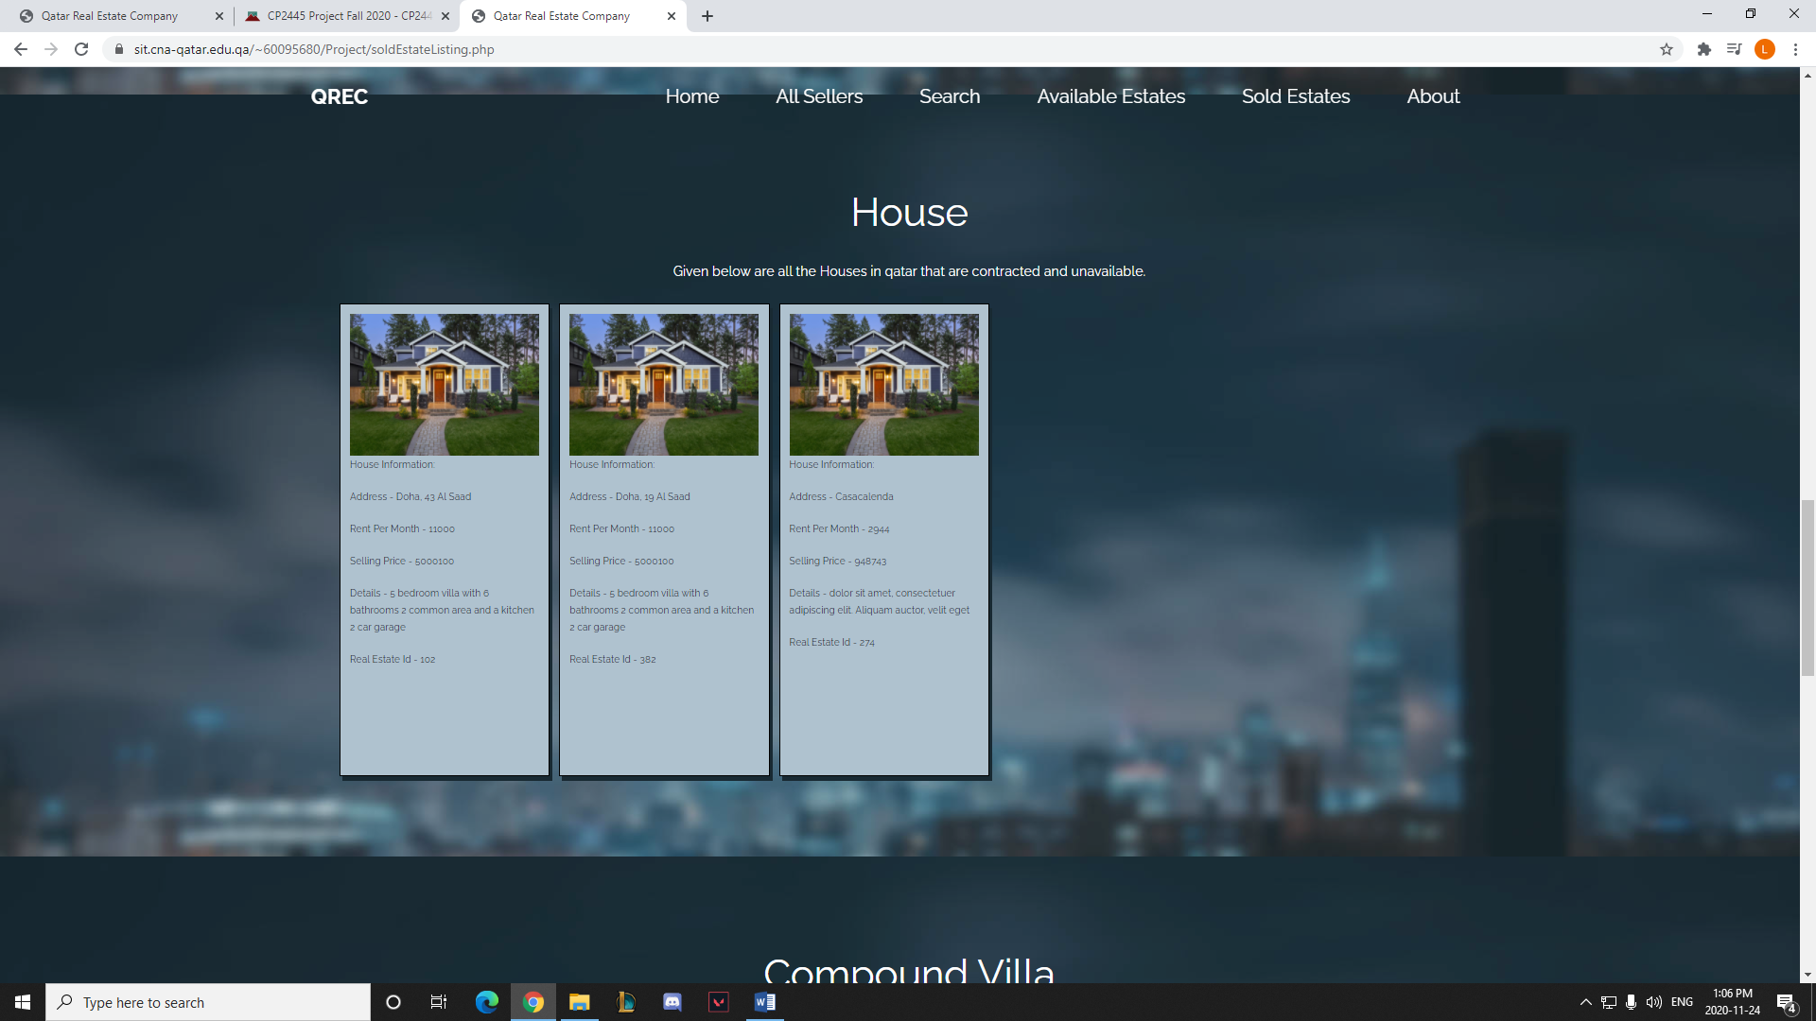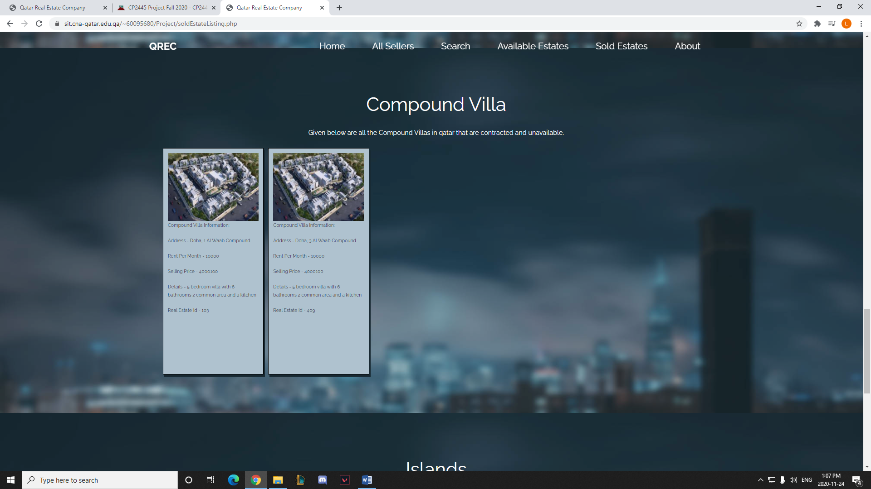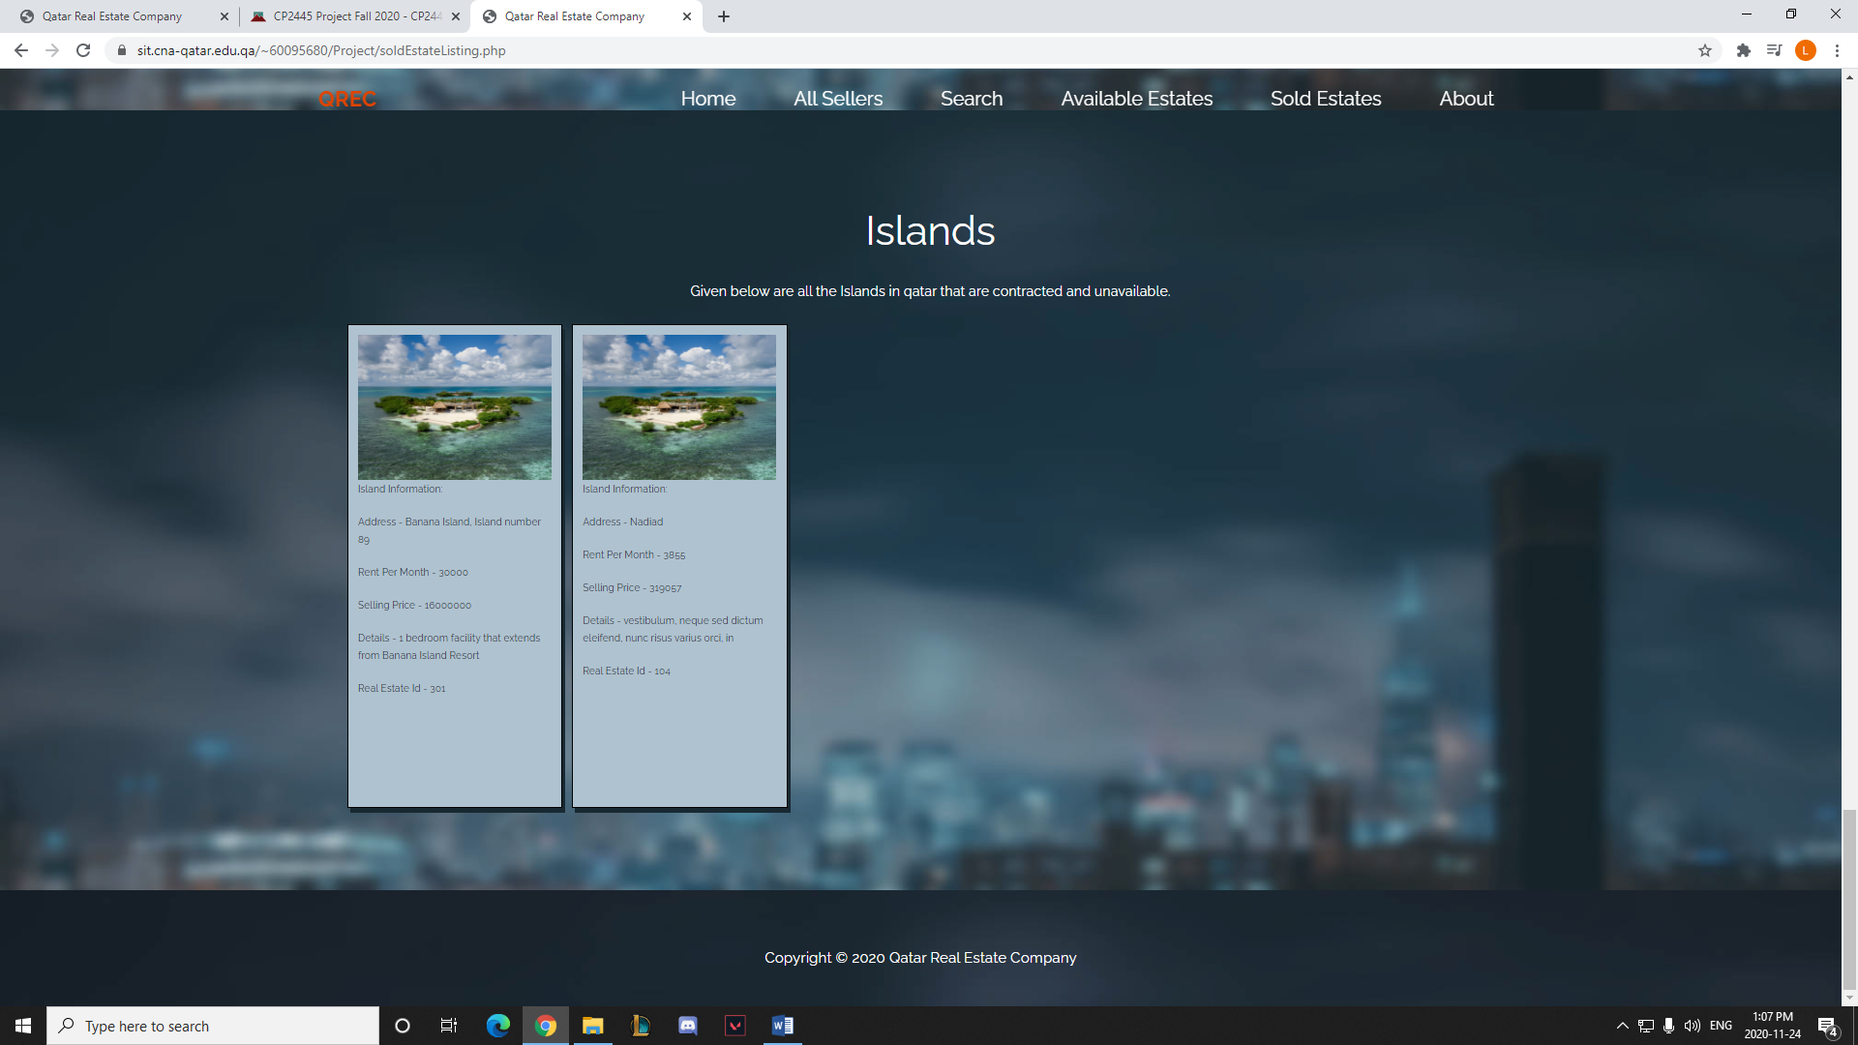

1. About (about.php)

Description: The About page displays all the information of employees at QREC in the case that a user wants to contact them for any information.

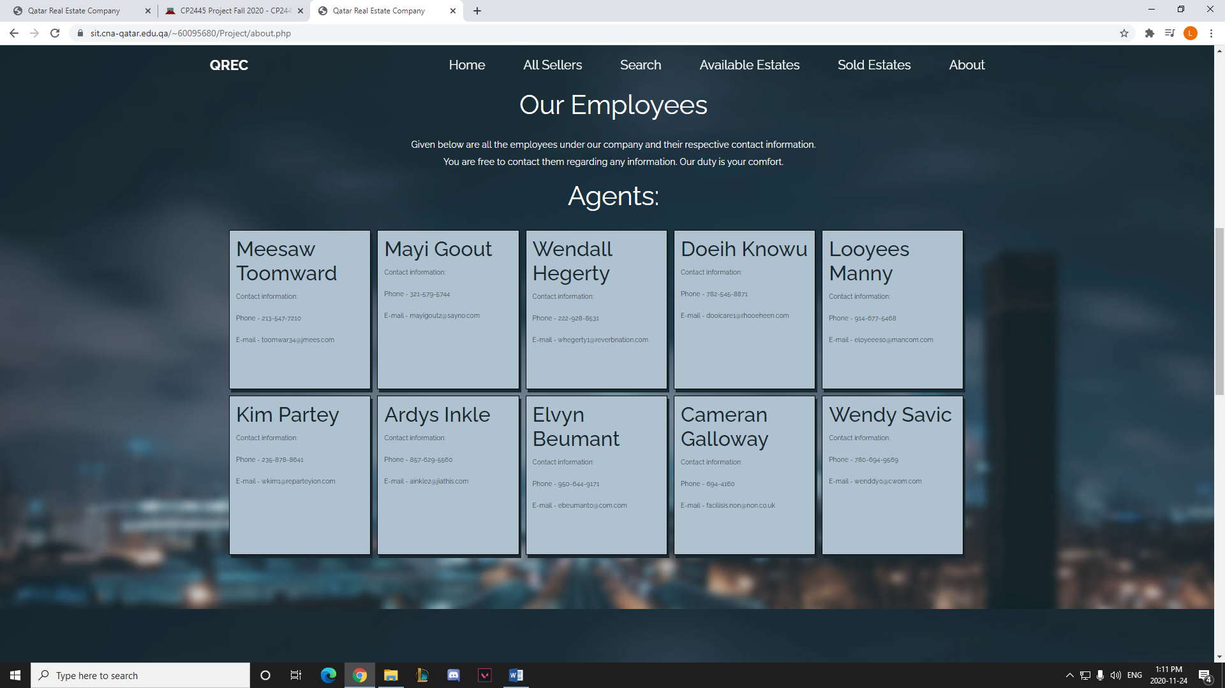

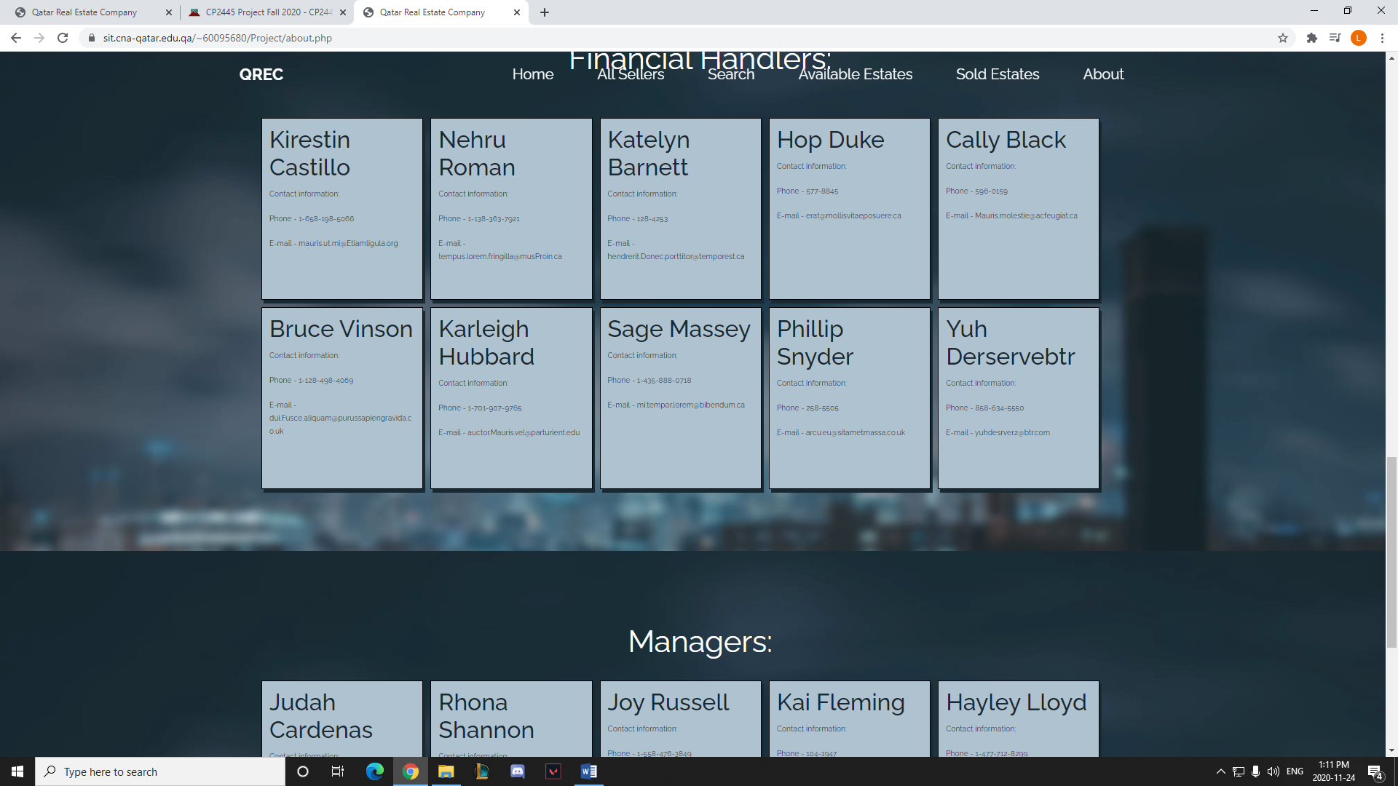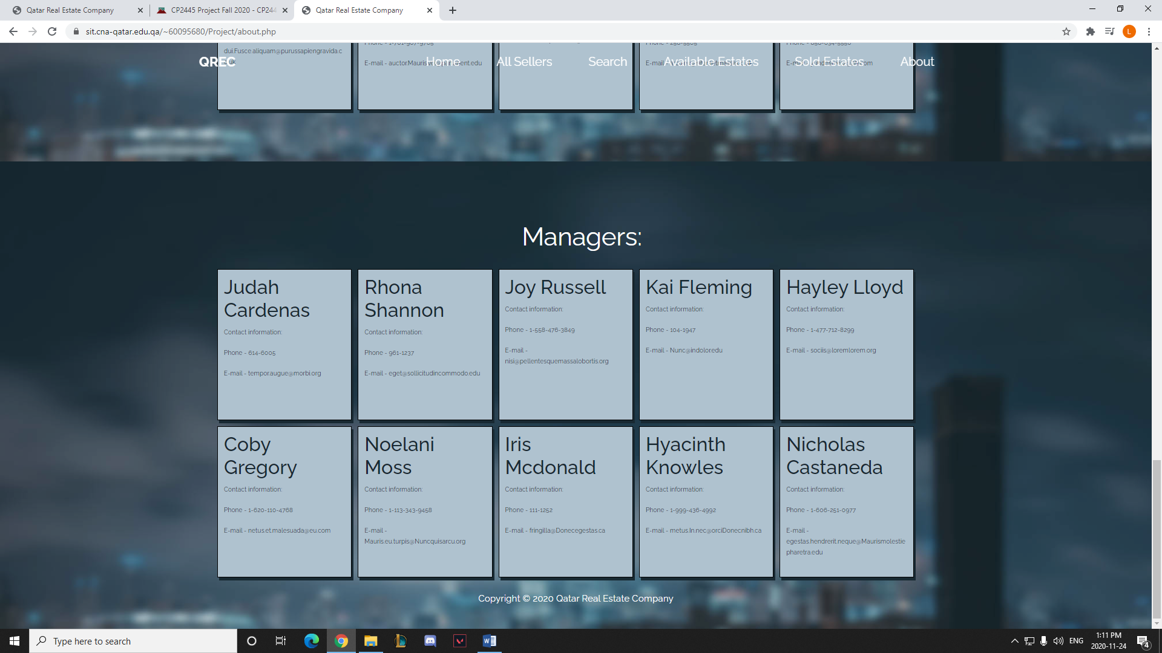

1. Appointment Form (bookappointment.php)

Description: The user can enter their details and choose to book an appointment which will then get saved in the database.

* + Uses processappointment.php to process inputs to save in the database

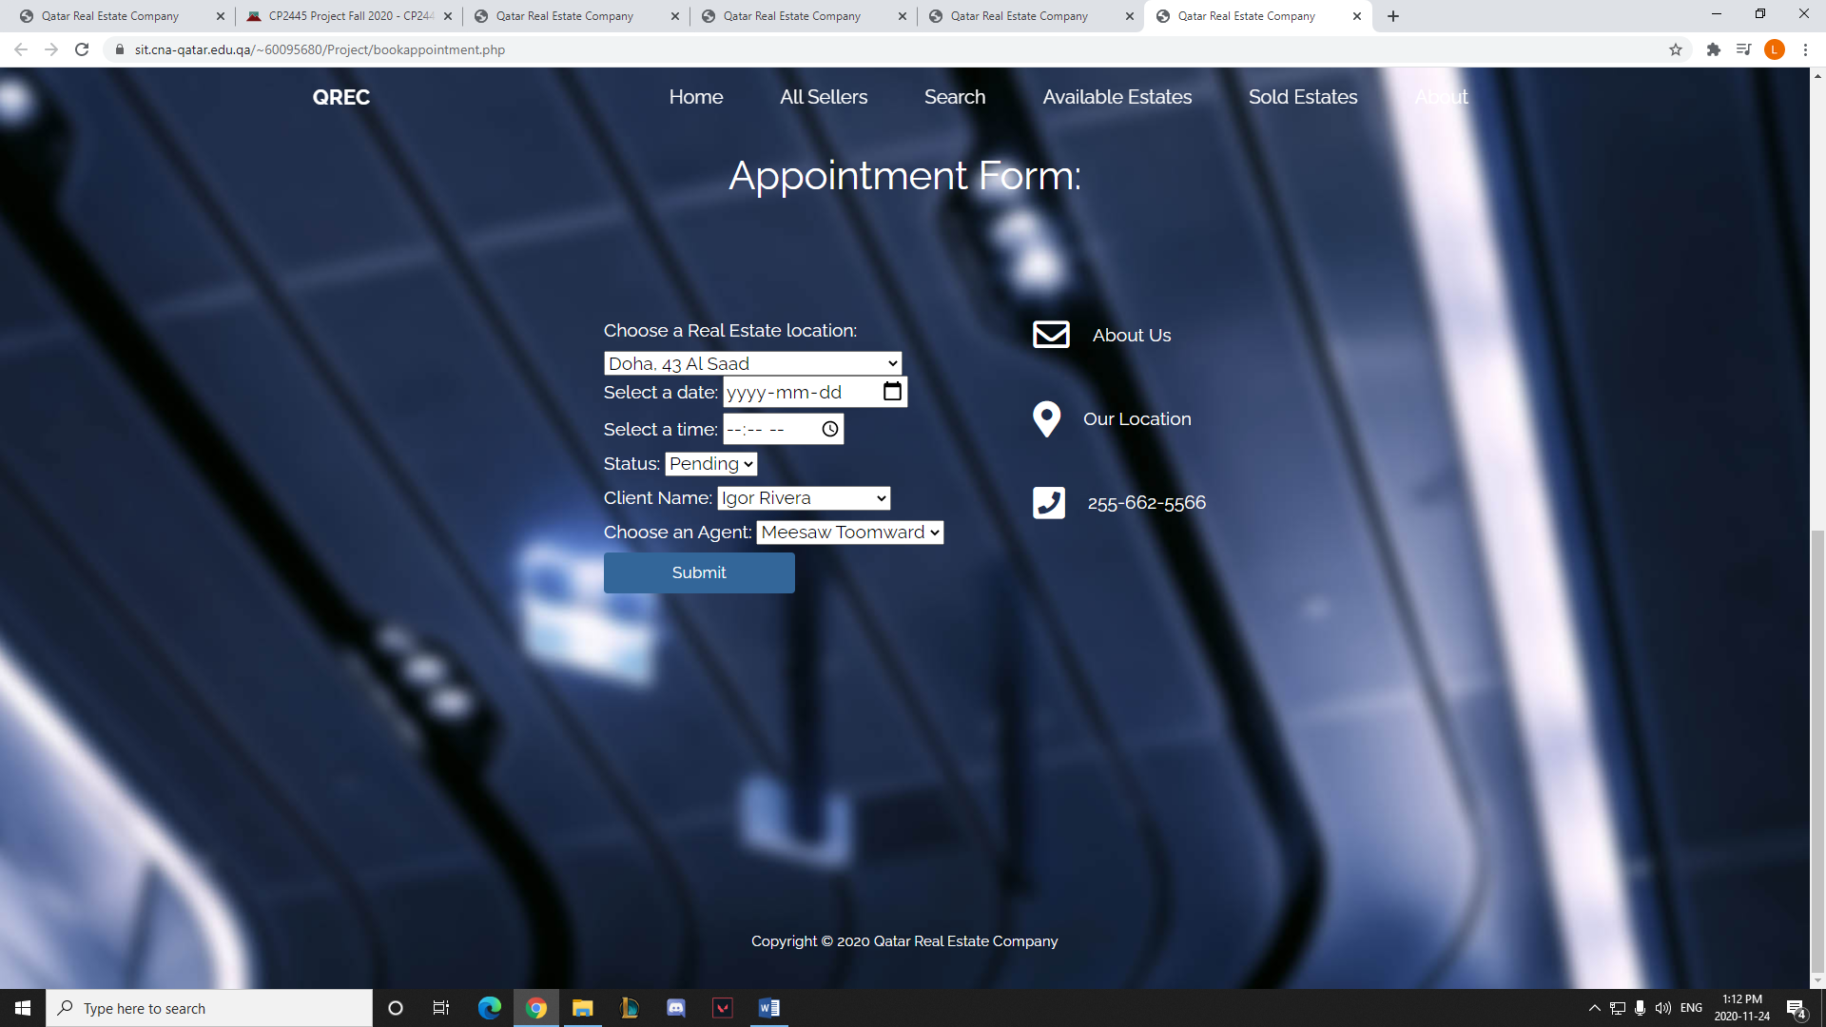

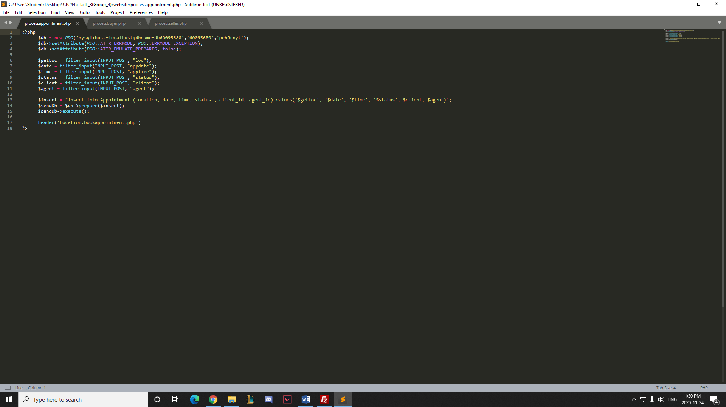

1. Buyer Form (buyercontract.php)

Description: The user can enter their details and choose to negotiate for the contract of a house which will then get saved in the database

* + Uses processbuyer.php to process inputs to save in the database

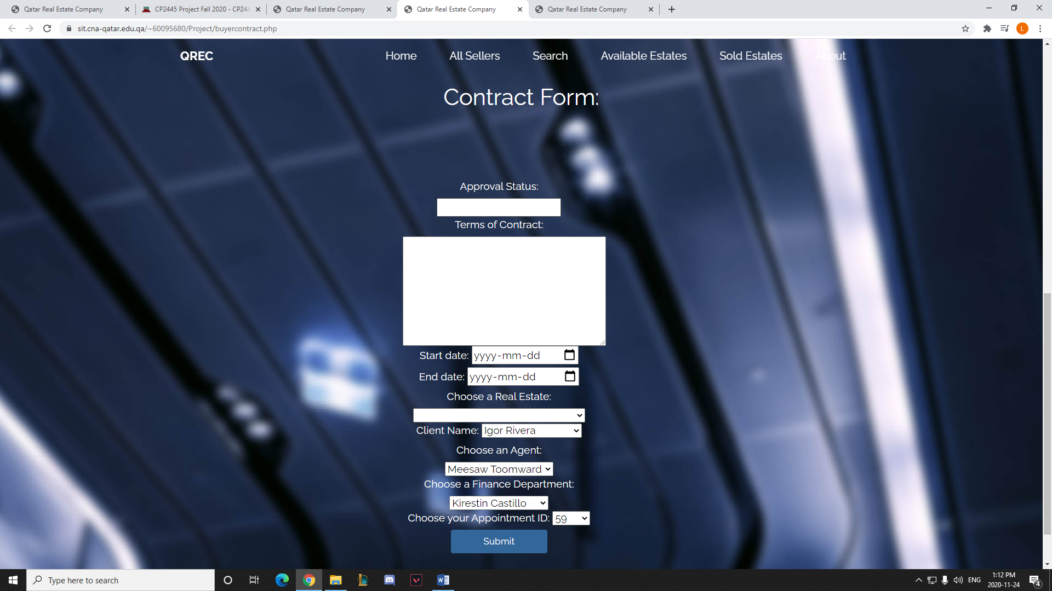

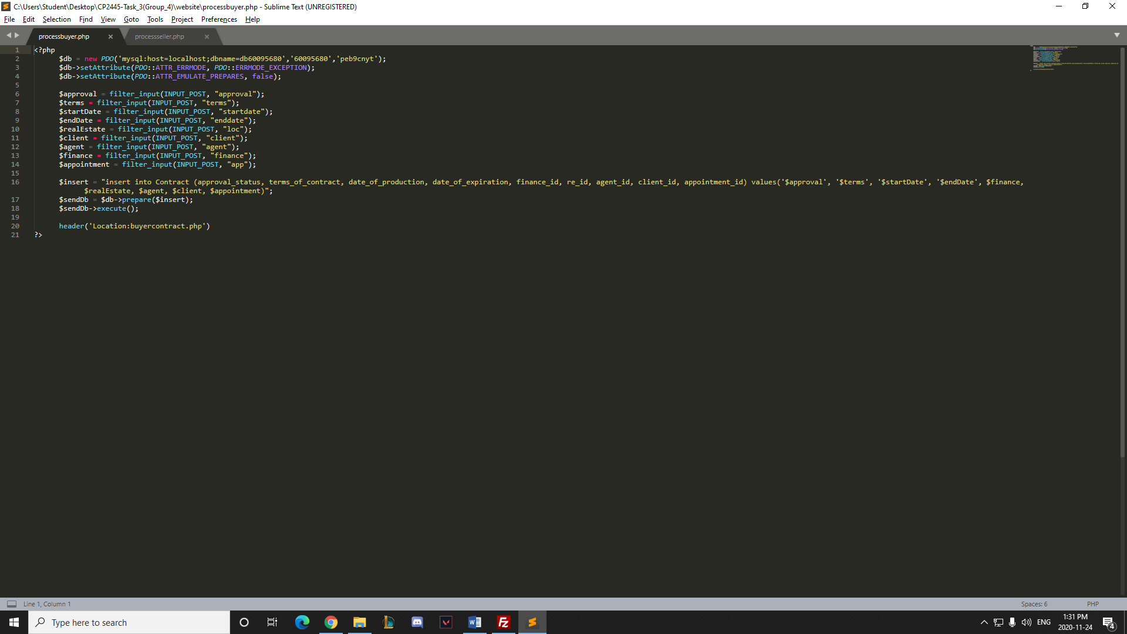

1. Seller Form (sellercontract.php)

Description: The user uploads information of an estate they would like to sell. This creates a new real estate as well as its linked component of type of real estate.

* + Uses processseller.php to process inputs and store the values of 2 tables in the database

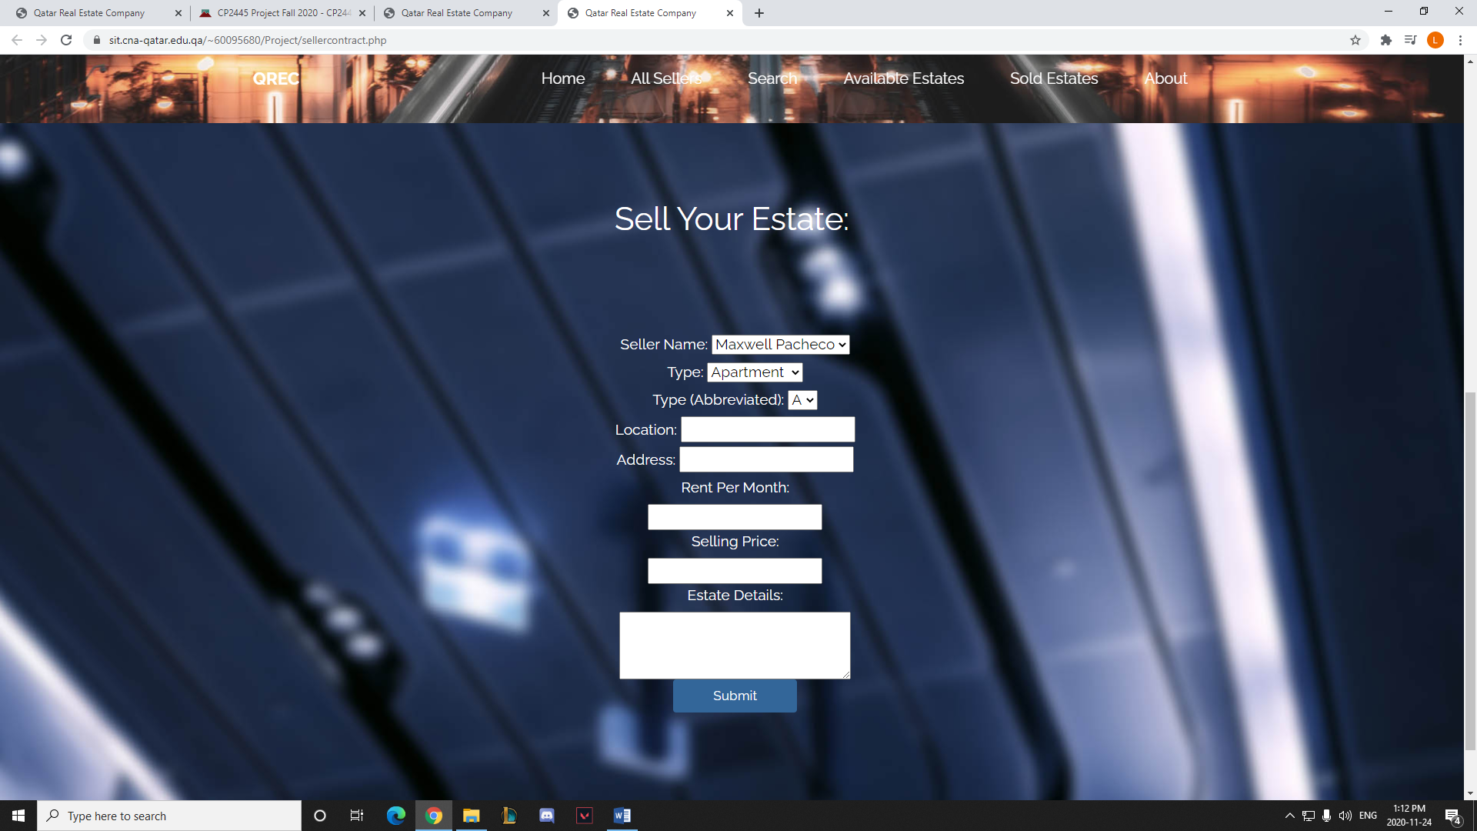

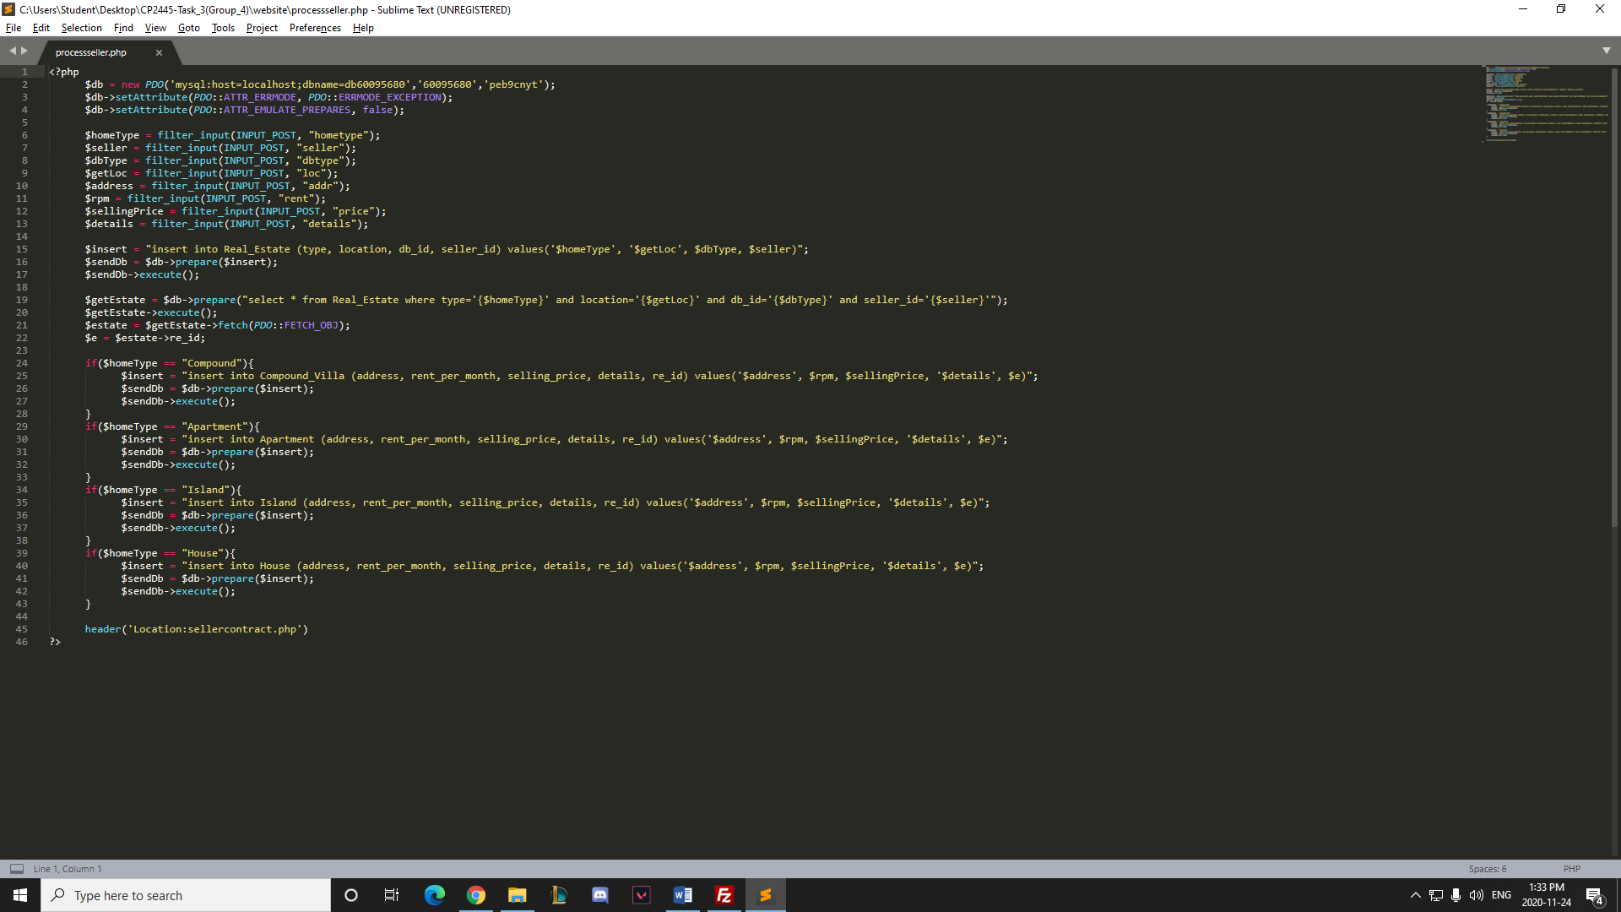

1. Admin page (adminpage.php)

Description: The Admin page is only available on the homepage beside the company name. It is supposed to be only for the use of employees. It displays links to all existing pages as well as the links to the list of Contracts, Buyer Purchases and All Available Clients.

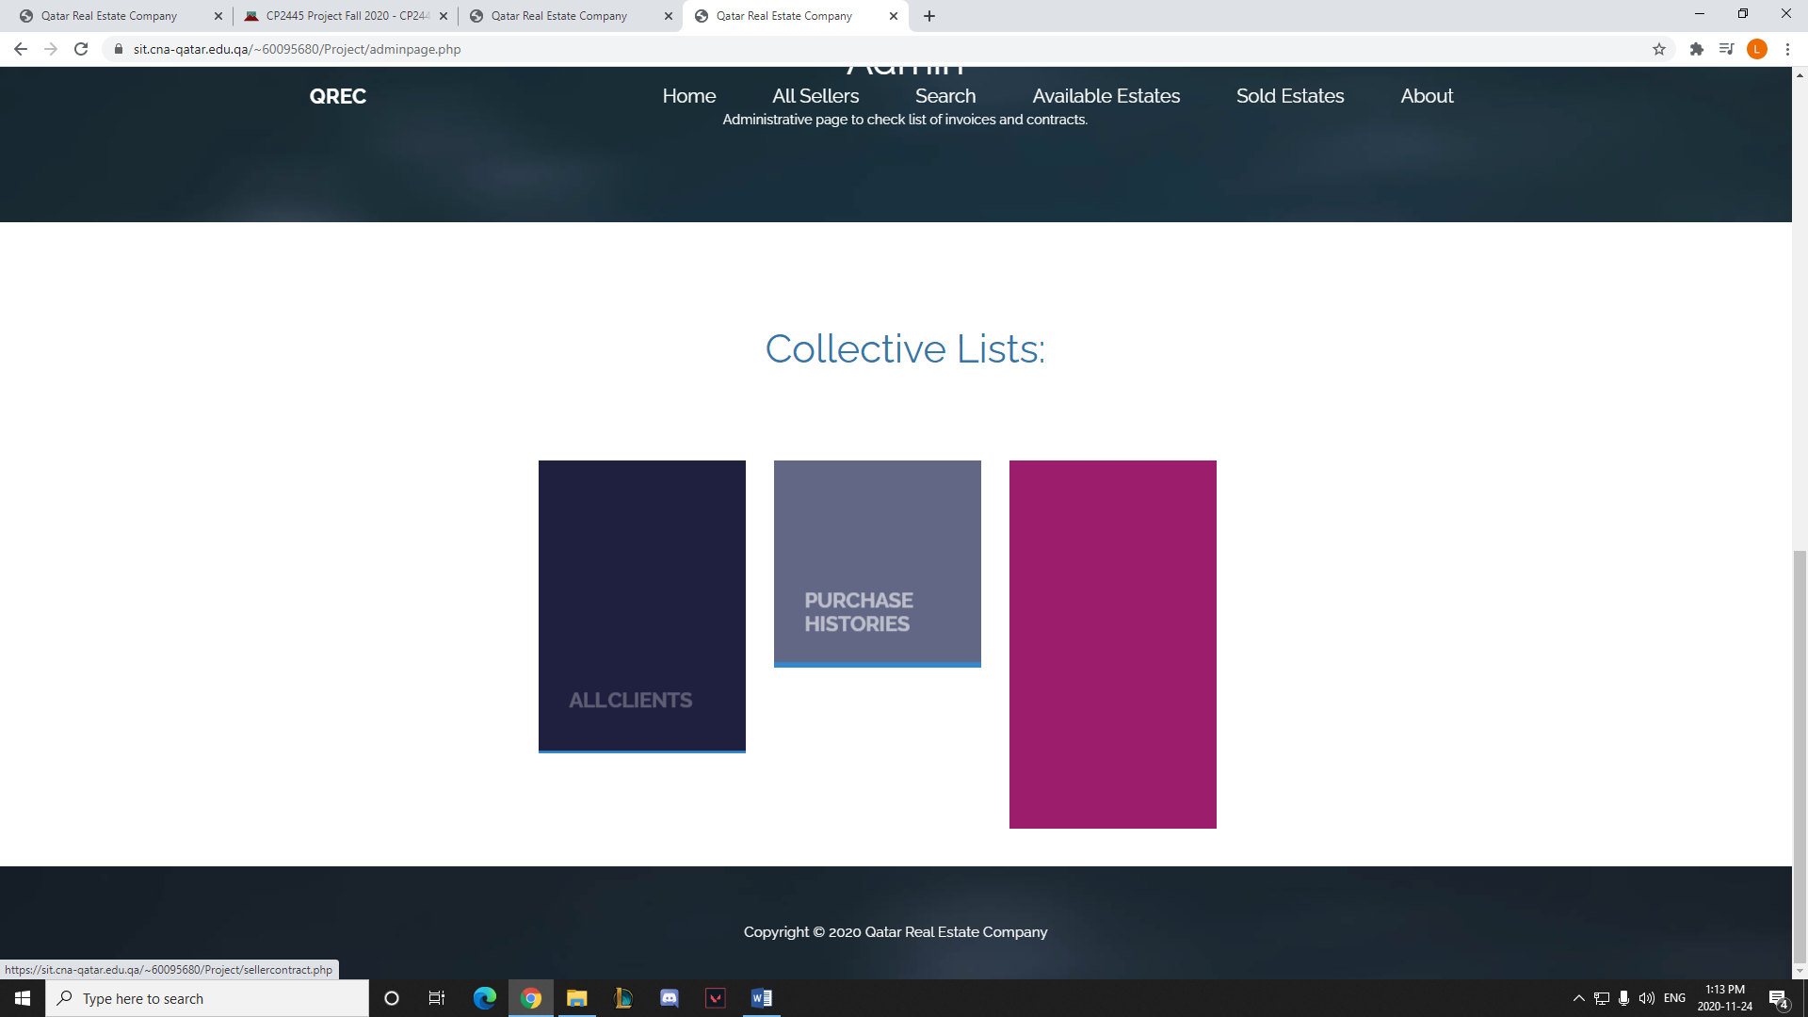

1. Contracts (contract.php)

Description: The Contracts page displays a table with all the contracts created by users which need to get approved or denied.

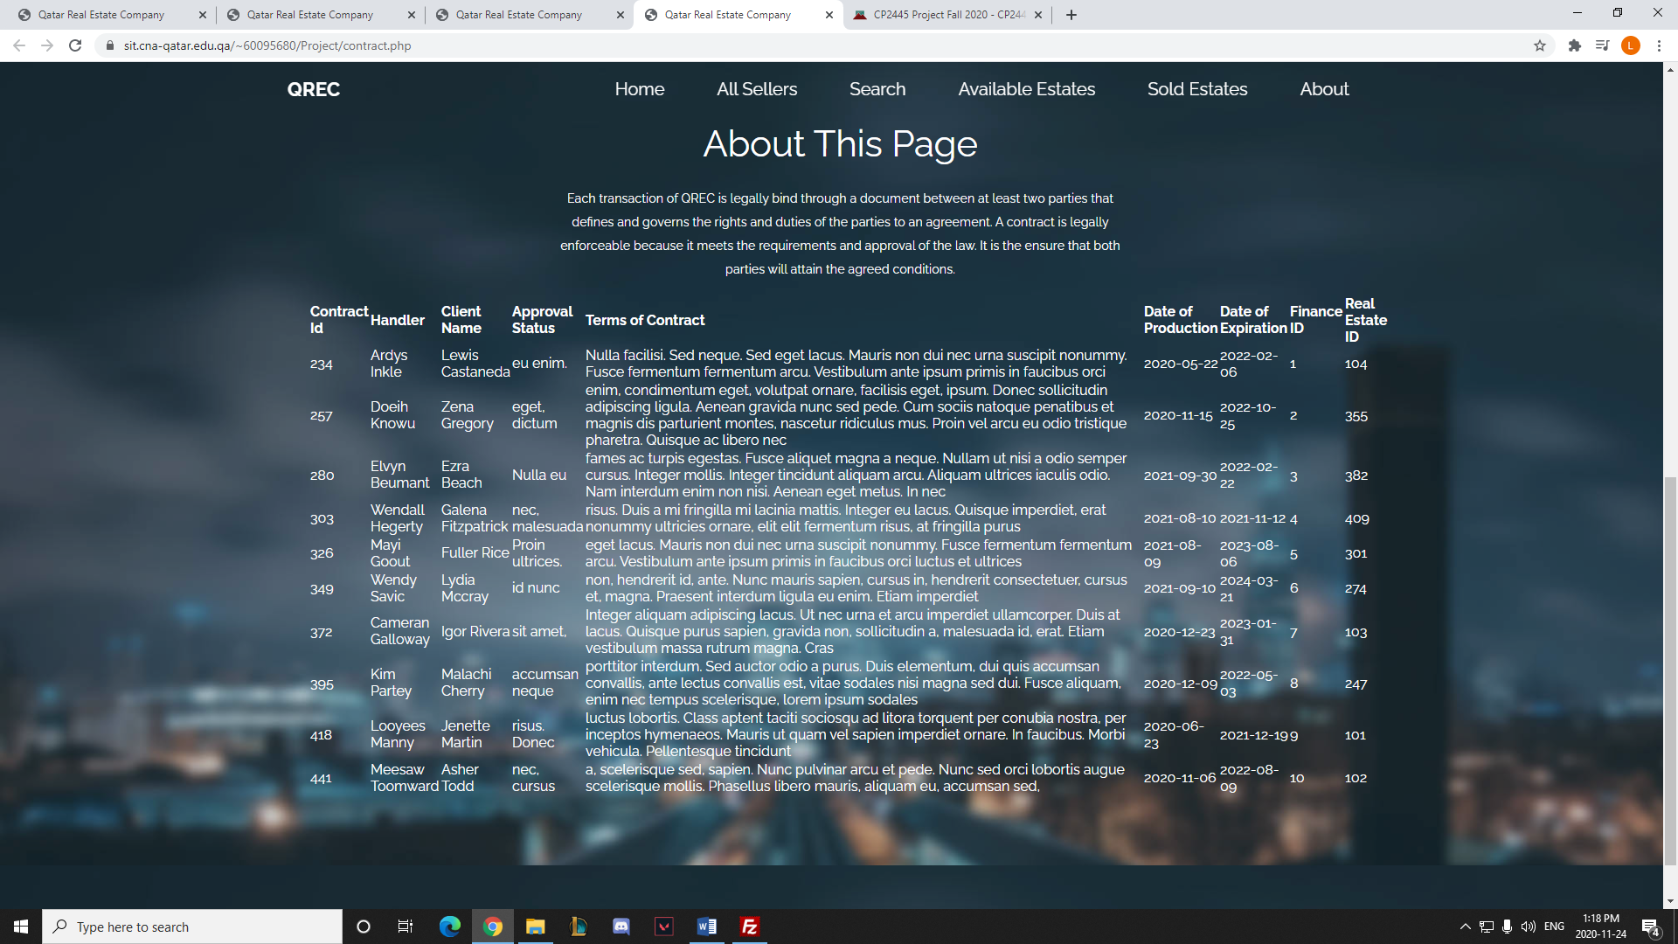

1. Purchases (buyerPage.php)

Description: This page stores all the information of processed data regarding the purchase of an estate.

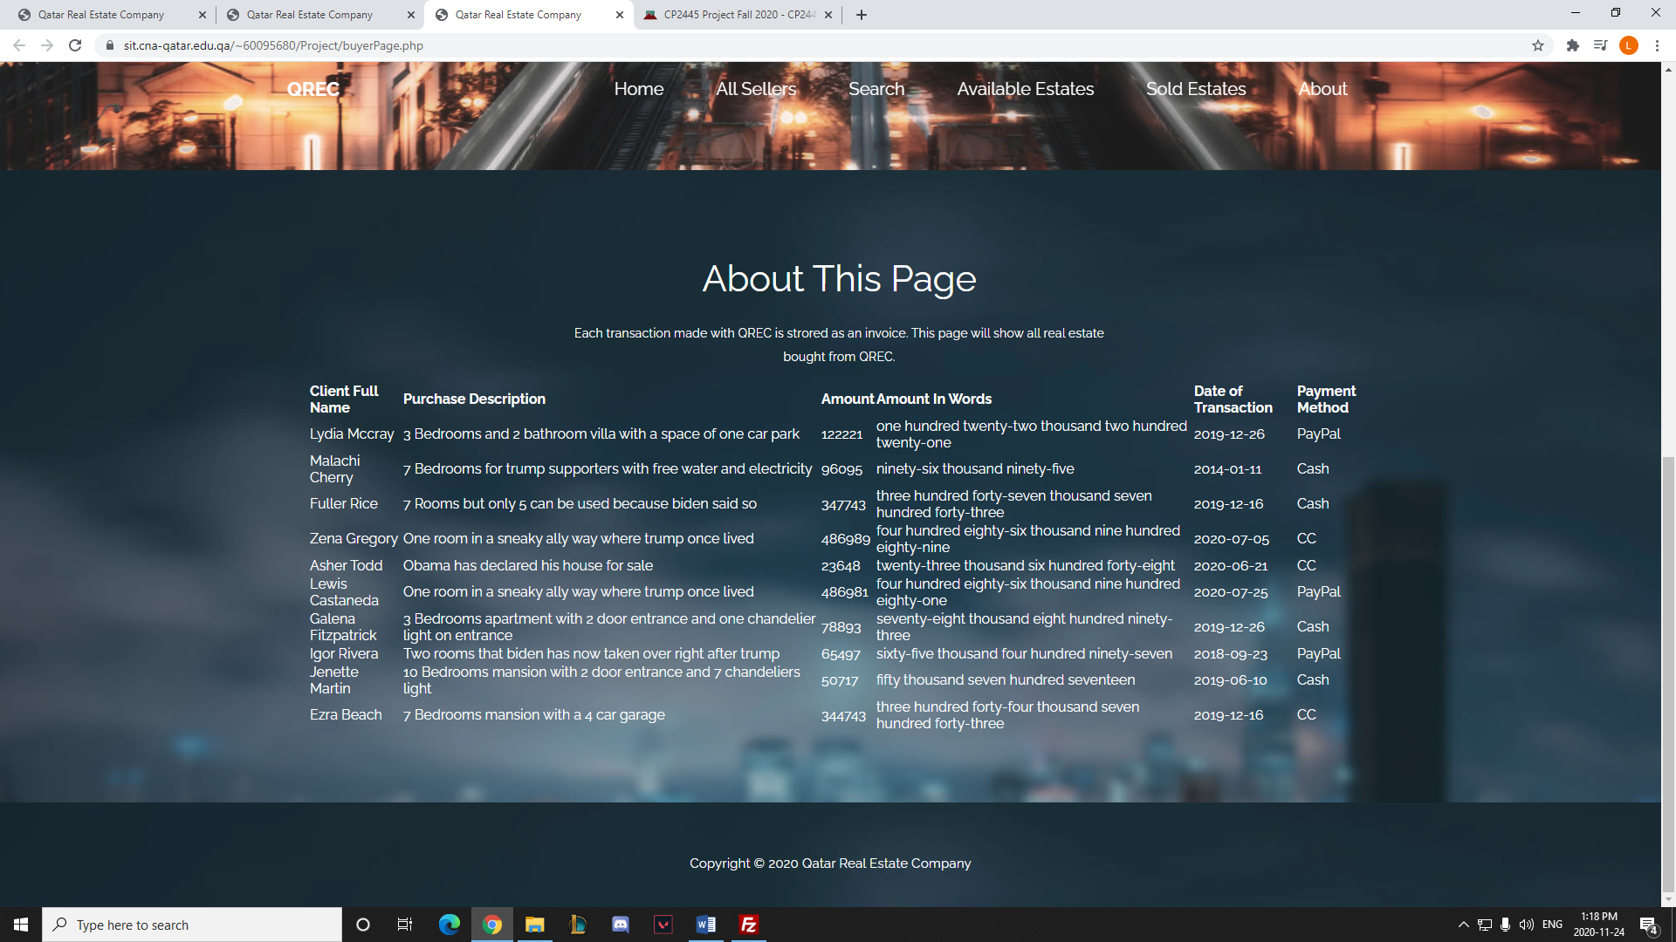

1. All Clients (allclient.php)

Description: All Clients page displays a list of all the available clients and their information.

